

WANG XINRUI (Student ID: A0186103M, Email: xinrui.wang@u.nus.edu)

REN JIEWEN (Student ID: A0186102N, Email: jiewen.ren@u.nus.edu)

ZHANG AO (Student ID: A0176595L, Email: e0232199@u.nus.edu)

LI LIPING (Student ID: A0186040M, Email: liping.li@u.nus.edu)

**Marketing Campaigns and Price**

**Optimization**

DSC 5101 ANALYTICS IN MANAGERIAL ECONOMICS

Group Project 3

1. **Executive Summary**

**1.1 Introduction**

Marketing campaigns promote a product through different media, including television, radio, posters, emails and messages. Businesses operating in highly competitive markets may initiate frequent marketing campaigns and devote significant resources to generating brand awareness and sales[1]. However, it is common for companies to struggle in measuring the campaign performance due to its complexity and intensiveness.

To come up with a consistent measure of campaign effectiveness, two major questions need to be tackled: how to tell if the marketing campaign has succeeded or not? What measurement metrics are we going to use? [2] The objective of this project is to design a consistent and robust measurement system by setting up control groups. Moreover, the result of the measurement will be used for different price discrimination methods which are often observed from transactions as an effective way to increase the market share and profit.

**1.2 Our Work**

To measure the campaign effectiveness, we pay attention to two important differences. One is related to the segmentation of customers and the other is “Ramadan” period. Linear regression models are run on these two binary variables and their interaction, with which we can interpret the coefficient as Ramadan campaign effectiveness. To find a comprehensive measurement, we use different dependent variables which includes response time and average amount of transaction for each customer. As several assumptions are made regarding the filter of the dataset, a few robustness tests are run to validate the result. In conclusion, we find that the campaign is effective in general because the coefficient is positive and statistically significant.

Based on our finding above, we then do customer segmentation for an optimal price discrimination strategy. In this report, section 2 will illustrate the methodology and logic for preparing data, including removal of meaningless information and joining of different datasets to obtain a consolidated data source; section 3 will present the results and findings, including whether each type of the discriminations exist and what could be the causes; the results will be further validated through robustness tests in section 4; and section 5 will wrap up the conclusions as well as limitations of this study.

**2. Research Methodology**

**2.1 Data Preparation**

Before we build the basic model, we would exclude some meaningless features in each dataset. First, in the campaign.csv, campaign_start_date and campaign_end_date overlap the information of campaign period in control and treatment datasets. We pay more attention to the specific date so we exclude the two from campaign. Then, neither campaign_source nor window_id have something to do with our campaign measurement. Second, we ignore the is_control variable in the customer_demographics. It is reasonable to rely on the treatment and control segmentation as provided in the separate tables. So an extra variable “is_control” distinguishing the two tables is added, which equals 0 in the treatment table and 1 in the other one. Third, we also notice that there are duplicates in the customer ID. For these duplicates, Last, we delete “X” in each dataset since row number represented by it should not be included in the model.

**2.2 Variables Analysis and Selection**

The dataset offers many variables and we need to decide which will be included in our regression model. Also, there is an imbalance in the dataset since the number of treatment customers is multiple of control customers. First, we take a look at number of samples in each subset.

|  |  |  |
| --- | --- | --- |
| **The Definition of Datasets** | | |
| control | no Ramadan messages received | |
| treatment | Ramadan messages received | |
| **dataset** | **observations** | **unique ID** |
| control before | 5545 | 1225 |
| control before p | 332 | 258 |
| control Ramadan | 313 | 239 |
| control after | 1218 | 1218 |
|  |  |  |
| treatment before | 52657 | 9809 |
| treatment before p | 2738 | 2251 |
| treatment Ramadan | 48684 | 9920 |
| treatment after | 9556 | 9556 |

Table 1. Definition of Datasets

Then we filter Ramadan and before Ramadan period, one customer is still related to numbers of transactions. In these four subsets, we group customers by their id and calculate ave_amount and ave_discount. For each customer, there are five corresponding variables will be used, we take age_2017 and member_age_2017 as control variables. Because the purchase behaviours may change with the increase of age. For interpreting the coefficient as elasticity, logarithmic transformation are applied to those numeric variables.

**3.Campaign Effectiveness: Baseline Model**

In order to test the Ramadan period campaign effectiveness, we start from a simple model to evaluate the changes in the avg_amount. In the DiD regression, we construct two binary variables treatment_customer and treatment_period, treatment_customer is 1 if the customer is in the treatment group, else is 0. Treatment_period is 1 in the Ramadan period, else is 0. Then We choose several control variables that have impact on the avg_amount. The baseline formula is given below.

ave_amount = β1*treatment_customer*treatment_period + β2*member_age_2017 + β3*age_2017 + β4* ave_discount

Refer to appendix 6.1 for baseline model 1 result. The coefficient of the interaction term in this model is positive and significant, which means the treatment customers will increase their avg_amount by 29.7% in Ramadan period. The conclusion from this model is that the Ramadan period campaign is significantly effective.

Then, we replace the y of baseline model as the response time, which is the time interval

Between the “m” and “p”, We filter the records that the event_tag is “m_p” to run the regression。

From the result, we find that the coefficient of the interaction term in this model is negative and significant, which means the treatment customers will decrease their response_time by 6.5% in Ramadan period, that’s to say, their response time between the message and purchase is shorter in Ramadan period than direct marketing. The conclusion from this model is also that the Ramadan period campaign is significantly effective. Refer to appendix 6.2 for baseline model 2 result.

**4. Campaign Effectiveness: Robustness Test**

We have also conducted robustness test for two baseline model. The results are shown as follows. The robust standard errors above are modified by White heteroscedasticity correction and they do not deviate much from our previous model. It seems there are not serious “thick tail” problem and coefficient estimations are efficient. So, we conclude that the model is robust. Refer to appendix 6.3 for robustness tests results.

**5. Price Discrimination**

**5.1 Third Degree Price discrimination**

Third Degree Price discrimination exists when: “two varieties of a commodity are sold by the same seller to two buyers at different net prices...”[3] In this scenario, different groups of customers can be charged different prices by receiving promo code/coupons of different level of discount rates. Different uniform prices are charged to different groups by sending different promotion coupons of various discount rates to different customers. To some extent, the seller can prevent arbitrage as they can limit the use of the coupon by individuals and by frequency.

**5.1.1 Customer Grouping**

Based on customers’ purchase behaviour, we have separated the customers into 3 groups: regular, price-sensitive and price-insensitive customers.

**Regular** customers should satisfy the following criterion:

1. event_tag == "p_p” - one’s purchase behaviour is irrelevant to the marketing campaign as he/she did not receive any messages before purchasing.

**Price**-**Sensitive** customers should satisfy the following criteria:

1. num_of_m > 0 - customer has received campaign messages
2. response_time <= 1 - purchase activity occurs within 14 days of receiving the message
3. discount >0 - the customer receives discount in that purchase

**Price-Insensitive** customers should satisfy the following criteria:

1. Not regular customers
2. Not Price Sensitive customers

**5.1.2 Demand Elasticity Comparison**

The regression model in appendix 6.4 reveals the demand elasticity comparison between different groups of customers. Assuming marginal cost is the same across sellers and they are all maximizing the profit, according to MR = MC, MR for all sellers should also be the same. On the other hand, MR = P(1 - η 1), where η 1 is the demand elasticity. Therefore, by comparing the net price of two groups of customers, we can derive the comparison of demand elasticity:

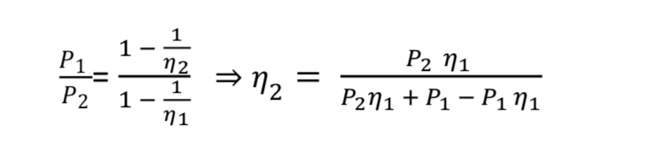

Using this formula, we achieve the following pricing scheme:

P sensitive = 0.858*P insensitive

For **regular** customers, their purchases are uncorrelated with whether they receive campaign messages, therefore we will not offer them any discounts. For **price insensitive** customers, we will need to collect more information on them - for example - their purchase record over a longer period, whether they have churned, reasons of their churn. For **price sensitive** customers, we should offer them 15% discount in order to motivate their purchase behaviour.

**5.2 Second Degree Price discrimination**

Second-degree price discrimination involves setting prices subject to the amount bought, to capture part of the consumer surplus. Retailers can achieve this by offering packages that encompasses quantity discounts, and consumers will choose the block that better suits them.[4]

**5.2.1 Customer Grouping**

We have separated the customers into 2 groups - **high-income** and **low-income** based on their average item price of their purchases. We first calculated the mean of average item price of all purchases, if their average item price is larger than the mean, we classified them into the "high-income" group, and vice versa.

**5.2.2 Analysis**

Appendix 6.5 indicates that high income and low-income customers have different demands, which makes second degree discrimination possible. High income customers demand fewer quantities compared to low income customers, implying that they may value quality over quantity. However, further design of packages can only be estimated with more information on product categories - such as what most popular products are in these two groups respectively.

**5.3 First Degree Price discrimination**

First Degree Discrimination requires producers to charge maximum price that each consumer is willing to pay to extract all consumer surplus. However, given the available information, we are not able to come up with an individual demand function for each individual customer.[5]

**5.4 Other Price Discriminations: Zone Pricing**

Retailers can also practice price discrimination in the form of zone pricing as it charges different prices in different regions. This allows retailers to speed up its growth in those profitable market without having to invest heavily on advertisements.

**5.Bibliography**

1. Machlup, Fritz. “Characteristics and Types of Price Discrimination.” *Business Concentration and Price Policy*, Princeton University Press, 1955.
2. VARIAN, HAL. “PRICE DISCRIMINATION.” *Handbook of Industrial Organization*, vol. 1, University of Michigan.

**6. Appendix**

**6.1 Baseline model 1**

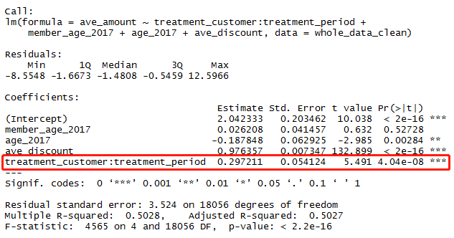

**6.2 Baseline model 2**

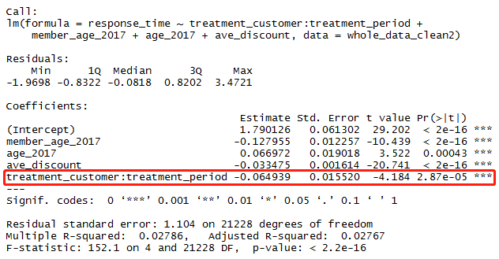

**6.3 Robustness tests results**

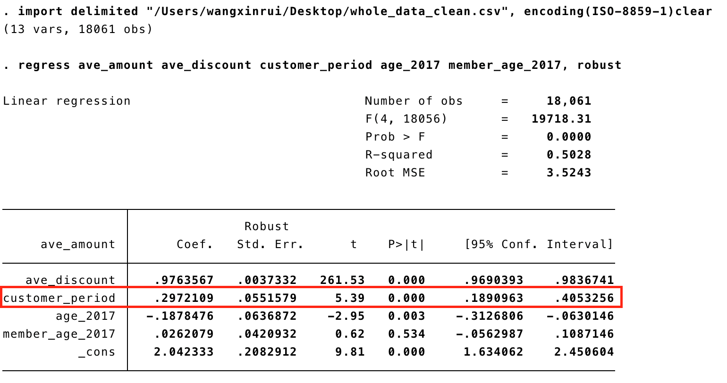

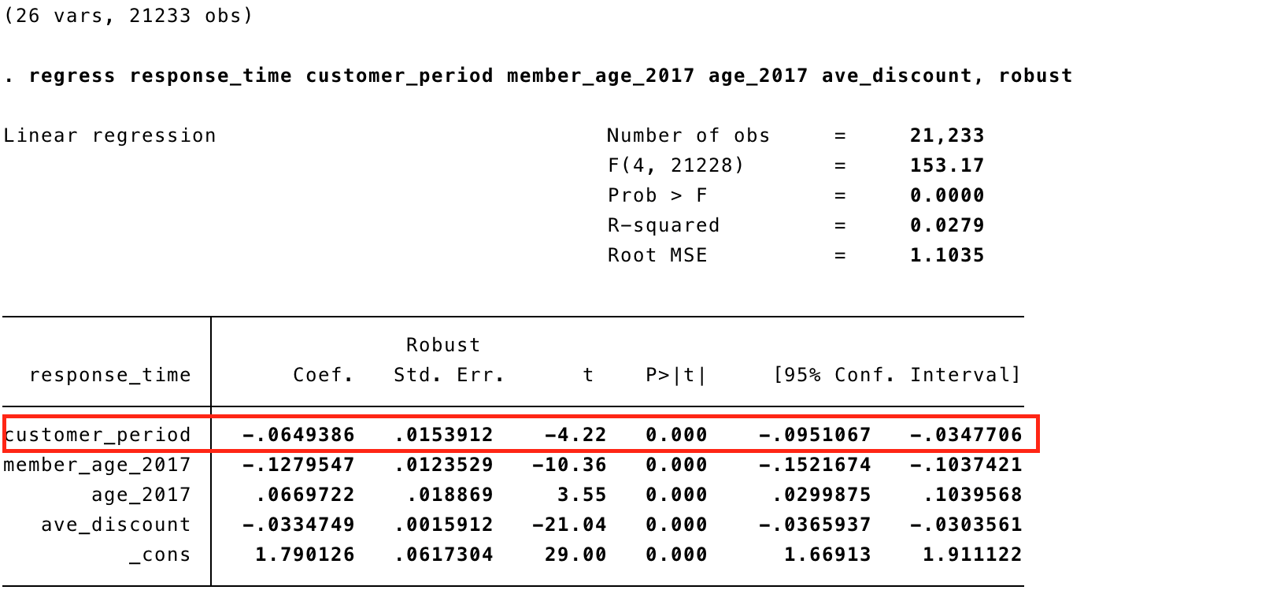

**6.4 Regression model for demand elasticity**

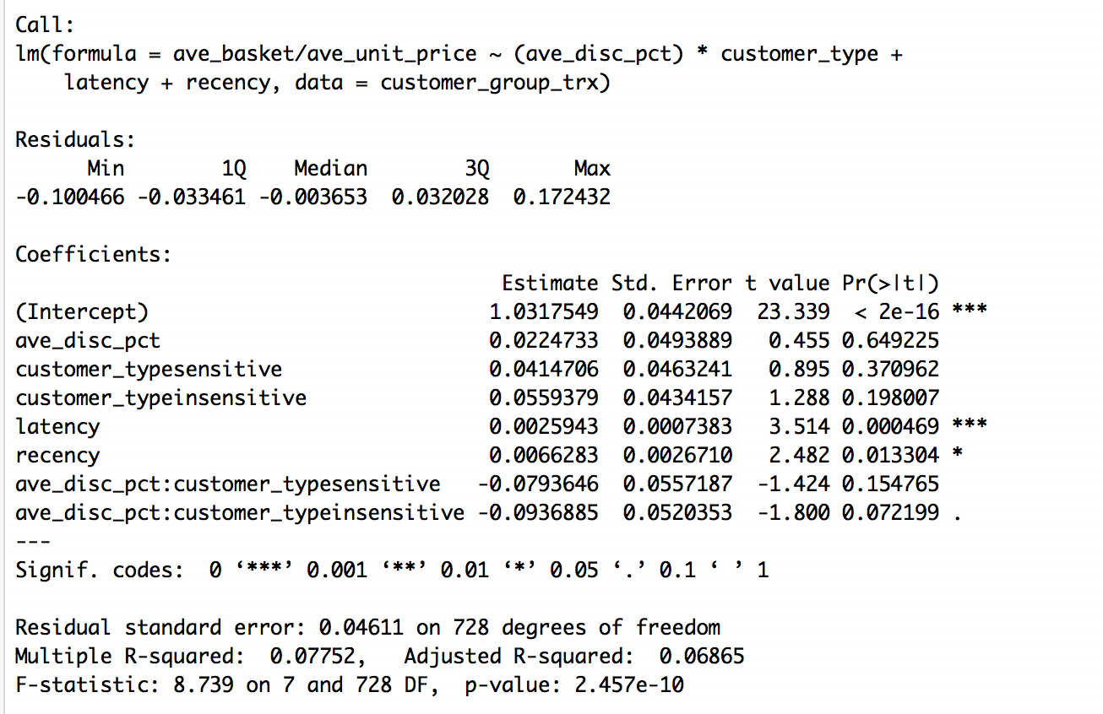

**6.5 Demand for high-income and low-income customers**

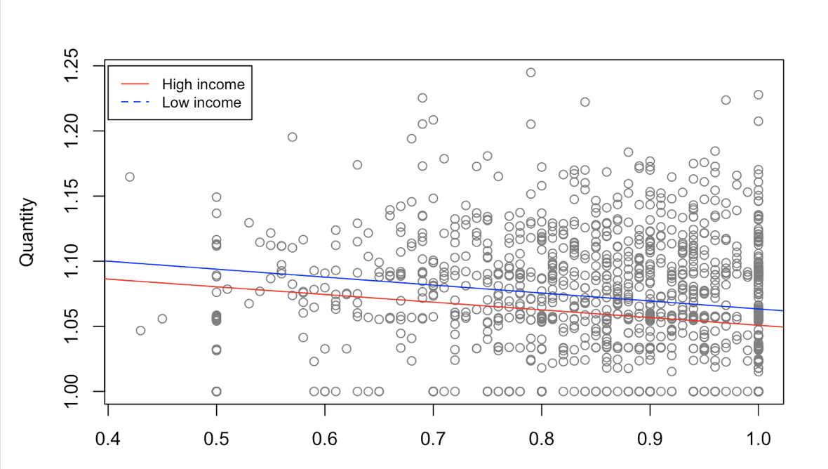

1. https://www.investopedia.com/terms/m/marketing-campaign.asp#ixzz5Vzi6eg2Y
2. https://www.thebalancesmb.com/how-to-run-a-successful-marketing-campaign-2948364
3. VARIAN, HAL. “PRICE DISCRIMINATION.” *Handbook of Industrial Organization*, vol. 1, University of Michigan.
4. https://policonomics.com/lp-monopoly2-second-degree-price-discrimination/
5. Machlup, Fritz. “Characteristics and Types of Price Discrimination.” *Business Concentration and Price Policy*, Princeton University Press, 1955.